For New Zealand Supply

NZ Tube Mills Limited (the "Company") of Lower Hutt, Wellington, guarantees the horticultural trellising system branded "Eco Trellis" and “Eco Beam” manufactured by it (the "Product") to be free from manufacturing defects in material and workmanship.
This guarantee expires 15 years after the date on which the Product is supplied (the "expiry date").
Claims made after the expiry date will be invalid.
The Consumer Guarantees Act 1993, the Fair Trading Act 1986 and other statutes may impose warranties, conditions or obligations on us which cannot by law (or which can only to a limited extent by law) be excluded. Other than as expressly provided in this guarantee, the Company excludes all such imposed warranties, conditions or obligations to the extent permitted by law and excludes any warranty, condition or obligation imposed or implied under common law, equity or otherwise.
The guarantees contained in the Consumer Guarantees Act 1993 are excluded where the Customer acquires the product from the Company for the purposes of a business in terms of sections 2 and 43 of that Act.
To the maximum extent permitted by law, the parties contract out of sections 9, 12A, 13 and 14(1) of the Fair Trading Act 1986.
The obligation of the Company under this guarantee is limited to (at its option) replacing (but not installing) that part of the Product that is defective or refunding the price paid by the Customer for the defective Product.
The Company will not in any circumstances be liable in contract or tort for any indirect or consequential loss, damage or liability of any kind suffered or incurred by the purchaser or any other person (including loss of profit).
This guarantee does not apply if:
The Product is improperly installed or cared for; or is subject to unusual conditions of use or adverse environmental circumstances; or non Eco Trellis or Eco Beam genuine parts and accessories are used in any way.
Claims must be in writing to the Company and must be supported by reasonable evidence of purchase.
Nothing in this guarantee relieves the Company from any obligations which it may not by law contract out of.

Signed
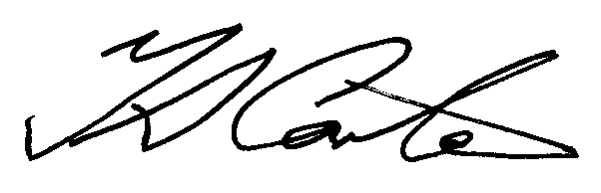
T Carter – General Manager
N Z Tube Mills Ltd

